|  |  |  |
| --- | --- | --- |
|  |  |  |
|  |  |  |
|  |  |  |
|  |
|  |
| Employee Data Report  ETLV done by using SQL and POWER Bi  **By: Bhawna Sharma**  **Data Source- Employee Database from MySQL website** |
|  |  |  |
|  |  |  |
|  |  |  |

# Sample SQL Queries used to explore data

### 1)Listing for all the Employees in the company: -

select emp_no, concat(first_name, ' ', last_name)as emp_name from employees

order by emp_name desc;

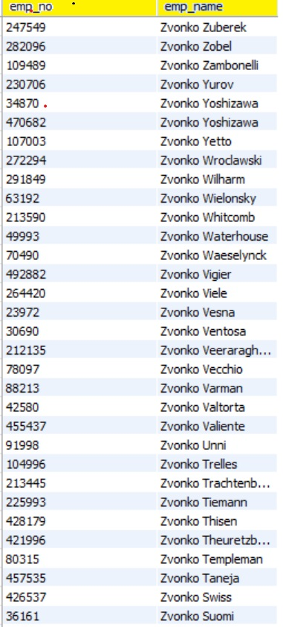

### 2)Listing for all the departments in the company: -

select dept_no, dept_name from departments order by dept_no asc;

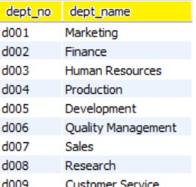

### 3)Listing all employees with their current titles: -

select concat(employees.First_name, ' ', employees.last_name) as Emp_Name, titles.title from employees

inner join titles on employees.emp_no = titles.emp_no

order by Emp_Name asc limit 50;

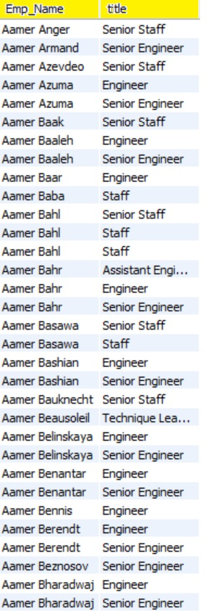

## Data Analysis using SQL

### 2.1) Total Number of Employees working in the organization:

select count(emp_no) from titles

'443308' employees in the organization.

### 2.2) Average salary by department

select avg(salaries.salary) as Avg_Salary, departments.dept_name from salaries

inner join employees on employees.emp_no = salaries.emp_no

inner join dept_emp on employees.emp_no = dept_emp.emp_no

inner join departments on dept_emp.dept_no= departments.dept_no

group by departments.dept_name order by Avg_Salary desc;

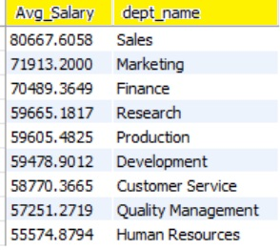

### 2.3) Top 10 highest paid employees

SELECT employees.emp_no, first_name, last_name, max_salary

FROM

(SELECT emp_no, MAX(salary) AS max_salary FROM salaries

GROUP BY emp_no) sal, employees

WHERE

employees.emp_no = sal.emp_no

ORDER BY max_salary DESC

LIMIT 10;

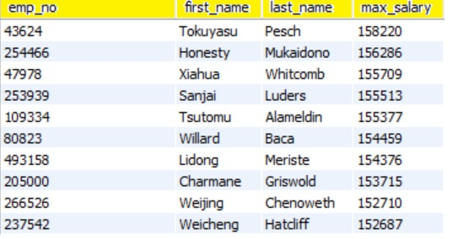

## Advanced Queries

### 3.1) Employee count by Department:

select distinct(departments.dept_name), count(dept_emp.emp_no) as Emp_Count from dept_emp

inner join departments on departments.dept_no = dept_emp.dept_no

group by departments.dept_name order by Emp_Count desc;

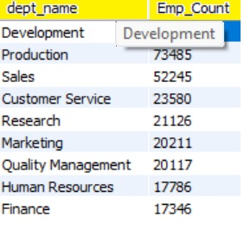

### 3.2) Salary Trend Over Time

SELECT YEAR (from_date) start_year, AVG (salary)

FROM salaries

GROUP BY YEAR (from_date)

ORDER BY start_year;

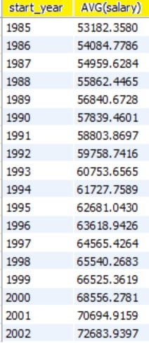

### 3.3) Gender Distribution by Department

select dept_no, sum(gender = 'F') as Female,

sum(gender = 'M') as Male from employees

inner join dept_emp on dept_emp.emp_no = employees.emp_no

group by dept_no;

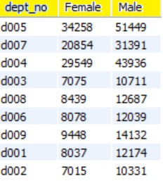

#### 3.4) Average tenure of Employees by Department

create table dept_avg_tenure as select departments.dept_name, avg(emp_tenure.tenure) from departments, emp_tenure, dept_emp

where

dept_emp.emp_no = emp_tenure.emp_no and

departments.dept_no = dept_emp.dept_no

group by dept_name;

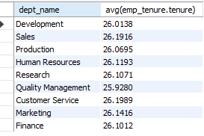

#### 3.5) Average Salary of Employees in different departments by different titles

Create table dept_title_avg_Sal as

select dept_name, title, avg(salary)

from departments

inner join dept_emp

using (dept_no)

inner join salaries

using (emp_no)

inner join titles

using (emp_no)

group by dept_name, title;